TC Cockpit Edit Project and Project General Info Update Deployment Guide

Revision History
Author | Revision Number | Date
TCSASSEMBER | 1.0 | 02/14/2011

Deployment Instructions 3
1. Organization of Submission 3
2. Application Setup 3
2.1 Ant .Properties File 3
2.2 Build Scripts Setup 3
3. Database Setup 4
4. Deployment Instructions 4
5. Starting 4
6. Verification 4
7. Resource Contact List 5

Deployment Instructions

Organization of Submission

The submission follows directory structure provided below:

doc
Contains the Deployment Guide Document of this assembly.

direct
Contains sources and static files for Direct web application. This directory replicates the application development distribution structure and includes only updated and new files.
db_scripts
Contains all the newly added / updated DDLs and queries for updating database script trunk
query
Contains all the newly added two queries
test_files
Contains the SQL files to insert new metadata keys for project ratings and SQL file to insert test data to verification.

Application Setup

The application is expected to be deployed to the following environment:

JRE 1.5
JBoss 4.2.3.GA
Informix DS 11.5

Ant .Properties File

No .properties files are modified.

Build Scripts Setup
The ANT build script for Direct application (build.xml) provides the following targets which are to be used:

- switch-and-checkout – checkout or switch to the defined source code branches for all components defined in subprojects.xml
- dist-backend – rebuilt all the components from the source code.
- first_deploy – must be the first task to execute from command line. It will copy all dependencies to your local JBoss folder.
- deploy – should be the main task to execute from command line. It will build and deploy WAR file.
- deploy-static-files – deploys the static files to JBOSS.
- deploy-apache-static – deploys the static files to apache server on VM.

Please refer here for more information:
http://www.topcoder.com/wiki/display/docs/TC+Direct+Setup+Guide

Database Setup

Add new metadata keys for project ratings
- Run test_files\insert_rating_metadata_keys.sql on database

Update and add queries via Query Tool

Log into the TC Query Tool to add the new query (on VM use http://tc.cloud.topcoder.com/query/query)

Add new query direct_project_general_info_projected_cost
- Choose the database TCS_CATALOG
- Create new query direct_project_general_info_projected_cost, click edit
- Paste the new query in query/query_direct_project_general_info_projected_cost.txt and Save
- Click query inputs and add the input: tcdirectid
- Add the new query to the existing command : direct_project_general_info

Add new query direct_project_general_info_projected_end_date
- Choose the database TCS_CATALOG
- Create new query direct_project_general_info_projected_end_date, click edit
- Paste the new query in query/query query_direct_project_general_info_projected_end_date.txt and Save
- Click query inputs and add the input: tcdirectid
- Add the new query to the existing command : direct_project_general_info

Deployment Instructions

This section provides the instructions in Production environment.

- Merge the code from submission into SVN for Direct application
- Build and deploy Direct application using ant deploy (or ant first_deploy ) command.
- Copy static files using ant deploy-static-files command or ant deploy-apache-static if use apache as static file server.

Starting

- Build and deploy the Direct application
- Start JBoss server instance hosting Direct application

Verification

Set up test data first, run the following SQL scripts in order against the test server database:
- test_files/test-data.sql

Run the tcs_dw load scripts to load the contest, direct projects, billing accounts and client data into tcs_dw
- If you test on VM, you can login as account tc, and go to /home/tc/web/scripts/dwload
- Run “./loadtcsscript.sh” to load data

Use various browsers to open the link http://localhost:8180/direct or https://[vm_ip]/direct , login as heffan / password.

Choose a project and open its project overview page, for example, http://cockpit.cloud.topcoder.com/direct/projectOverview?formData.projectId=10000004

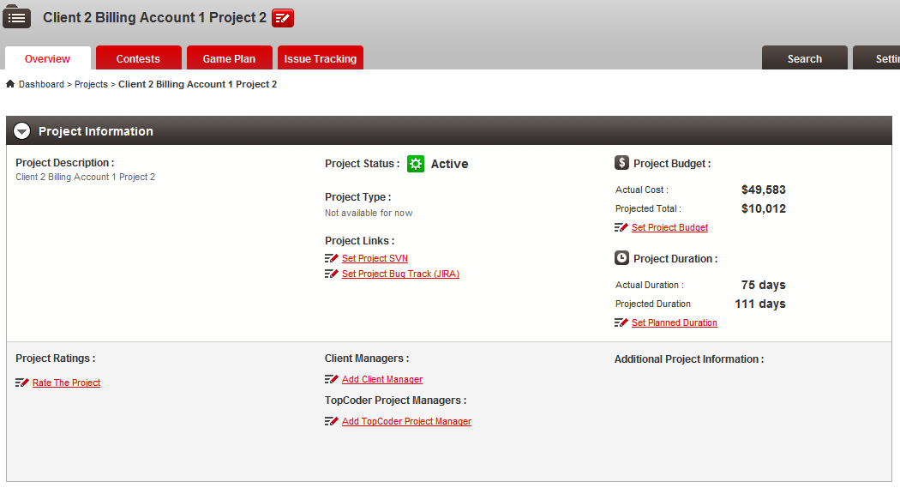

You can check each edit link. They are displayed when that section has no data set in project edit. Click Edit Project button, or any edit link to go to the edit project page.

Check the bottom of the edit project page, the Project Ratings should be displayed.
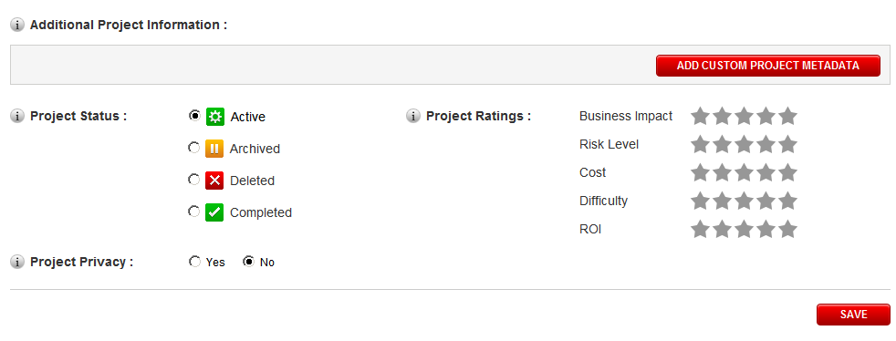

Add project information:
- Client Manager Handles
- Project Manager Handles
- Project Budget
- Project Duration
- Project SVN Address
- Bug Tracker Address

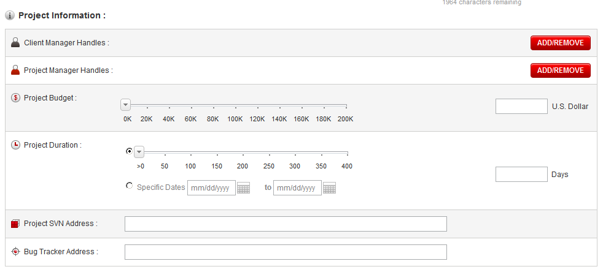

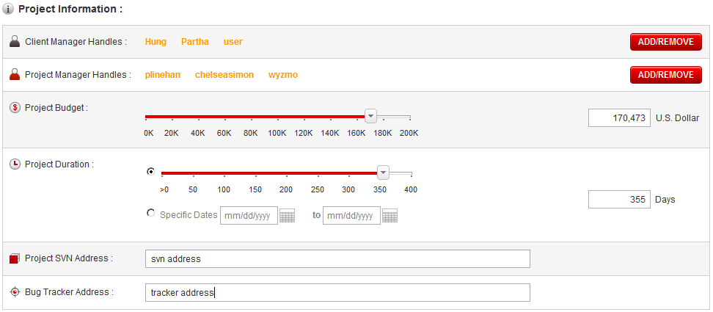

Change Project Status and Set Project Ratings

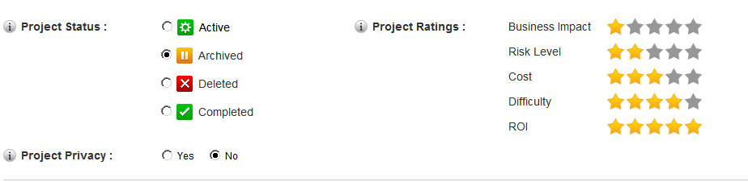

Then click the Save button, the page will be redirected to the project overview page, now you can see added info are displayed. The project status is changed to archived so the Project Duration is not displayed.

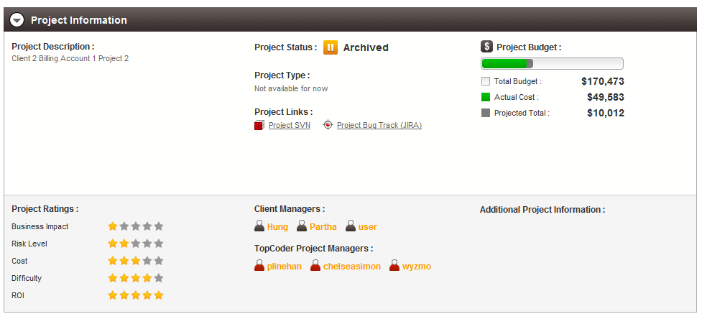

Now edit this project again to change project budget and project duration to a small value and add custom project metadata

Create a new custom key and click saves

Then add 3 values for the new added key

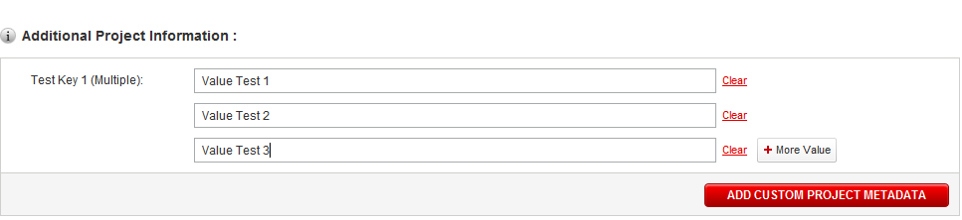

Do the similar process to add another key and change the project status back to Active, and click the save button

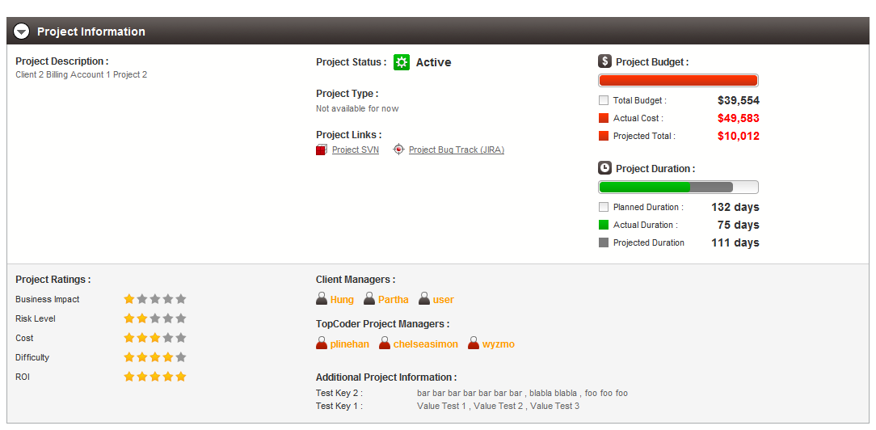

Resource Contact List

Name | Resource Email
TCSASSEMBER

